**DESIGN AND ANALYSIS OF VARIOUS MECHANICAL PARTS AND GENERATE PART PROGRAMME CODES FOR OPTIMAL MANUFACTURING**

PROJECT REPORT

Submitted by

**HARIKRISHNAN K (LNML17ME020)**

**ASHWIN P (NML17ME008)**

**ANURAG P (NML17ME007)**

to

*the Kerala Technological University*

*in partial fulfilment of the requirements for the award of B.Tech Degree*

*in Mechanical Engineering.*

|  |
| --- |
|  |

**Department of Mechanical Engineering**

NORTH MALABAR INSTITUTE OF TECHNOLOGY

KANHANGAD-671315

JUNE 2021

**DEPARTMENT OF MECHANICAL ENGINEERING**

**NORTH MALABAR INSTITUTE OF TECHNOLOGY,**

**KANHANGAD 671315**

|  |
| --- |
|  |

**CERTIFICATE**

This is to certify that the project report entitled “**DESIGN AND ANALYSIS OF VARIOUS MECHANICAL PARTS AND GENERATE PART PROGRAMME CODES FOR OPTIMAL MANUFACTURING**” is a bonafide record of the work done by **HARIKRISHNAN K, ASHWIN P, ANURAG P** under my supervision, in partial fulfilment of the requirements for the award of the Degree of Bachelor of Technology in Mechanical Engineering from APJ Abdul Kalam University for the year 2017-2021.

JOBEL JOSE (Name and Signature)

Asst Professor Head of the department

NMIT Kanhangad (with seal)

**DECLARATION**

I **HARIKRISHNAN K, ASHWIN P, ANURAG P** hereby declare that, this project report Entitled **DESIGN AND ANALYSIS OF VARIOUS MECHANICAL PARTS AND GENERATE PART PROGRAMME CODES FOR OPTIMAL MANUFACTURING** is the bonafide work of mine carried out under the supervision of **Mr.JOBEL JOSE** Assistant professor, department of mechanical engineering for the partial fulfilment for the award of degree of Bachelors of Technology of APJ Abdul Kalam Technological University, Kerala. This submission represents my ideas in my own words and where ideas or words of others have been included. I have adequately and accurately cited and referenced the original sources. I also declared that i have adhered to ethics of academic honesty and integrity and have not misrepresented or fabricated any data or idea or fact or source in my submission. I understand that any violation of the above will be a cause for disciplinary action by the institution and/or the university can also evoke penal action from the sources which have thus not been properly cited or from whom proper permission has not been obtained. This report has not been previously formed the basis for the award of any degree, diploma or similar title of any other university.

Place: NMIT, Kanhangad HARIKRISHNAN K

Date ASHWIN P

ANURAG P

**ACKNOWLEDGEMENTS**

I take this opportunity to express my deep sense of gratitude and sincere thanks to all who helped me to complete the project entitled “**DESIGN AND ANALYSIS OF VARIOUS MECHANICAL PARTS AND GENERATE PART PROGRAMME CODES FOR OPTIMAL MANUFACTURING**” successfully.

Many thanks goes to the Principal and management of **North Malabar Institute of Technology** for providing the best facilities and atmosphere for conducting the project.

I am deeply indebted to my guide **Mr.JOBEL JOSE** Assistant professor, department of mechanical engineering for his for his excellent guidance, positive criticism and valuable comments.

I am greatly thankful to Head of Mechanical Engineering Department for his support and cooperation.

Finally, I thank my parents and friends near and dear ones who directly and indirectly contributed to the successful completion of my project.

Place :

Date :

**ABSTRACT**

Naturally, a difficult product design and would trigger a noticeable gap between the design model and the actual product. Genetic algorithm is one of the widely used approach for solving complex real-world problems compared with traditional optimization methods. But it is time consuming and initial data dependent. Fusion 360, a product introduced by Autodesk is a widely used industrial software comprises of design, simulation and CAM modules, turns out to be the key for next generation manufacturing. Here we use fusion 360 software for generating program code and for other analysis.

Fusion 360, a product introduced by Autodesk and integrating industrial

Design , structural design, mechanical simulation, and CAM, turns out a design platform

supporting collaboration and sharing both cross-platform and via the cloud. In previous products, design and manufacturing use to be isolated. In the course of design, research and development,the communication between designers and engineers used to go on through different software products, tool commands, and even industry terms. Moreover, difficulty also lies with the communication between design thoughts and machining strategies. Naturally, a difficult product design and R & D process would trigger a noticeable gap between the design model and the actual product. A complete product development process tends to cover several major areas, such as industrial design, mechanical design, rendering and animation, computer aided emulation (CAE), and computer aided manufacturing (CAM). Fusion 360, a perfect design solving the technical problems of cross-platform data exchange, realizes the effective control of cross-regional collaboration and presents an overview of collaboration and breaks the barriers between art and manufacturing, and blocks between design and processing. The “Eco-development of Fusion360 Industrial Chain” is both a significant means to and an inevitable trend for the manufacturers and industrial designers to carry out innovation

Fusion 360 could perform an automatic control and optimization upon a CNC machining, while providing tools for users to carry out a secondary development. The determination of optimal cutting parameters have significant importance for economic machining in minimizing of particular operating mistakes like tool fraction, wear , and chatter. Generating program codes using fusion 360 can make a great improvement in machine operations namely multi pass turning.

Key words : Design, Analysis, Optimization, Fusion 360

**CHAPTER 1**

**INTRODUCTION**

* 1. **MOTIVATION**

In conventional CNC machine, the codes are manually written and feed to the machine. It is not an efficient method when time is considered as a constrain. Long cutting tool travel path results in higher cutting time . The CTTP should be optimized to decrease the travel time.

Naturally, a difficult product design and would trigger a noticeable gap between the design model and the actual product. Genetic algorithm is one of the widely used approach for solving complex real-world problems compared with traditional optimization methods. But it is time consuming and initial data dependent.

Fusion 360, a product introduced by Autodesk is a widely used industrial software comprises of design, simulation and CAM modules, turns out to be the key for next generation manufacturing. Here we use fusion 360 software for generating program code and for other analysis.

We reached three objectives to fulfill our project, they are

1) To find an efficient solution approach to determine the best sequence of operations for a set of operations that are located in asymmetrical locations and different levels.

2)To generate part program code for optimal manufacturing.

3)To analyze the quality of the product.

|  |
| --- |
| CAD/CAM Software Fusion 360 CLOUD Commercial New for 1 Year (Electronic  License) | CAD/CAM Software on Alzashop.com |

**CHAPTER 2**

**LITERATURE SURVEY**

**2.1** **Current 3.O Era Design Trend of Multi – disciplinary Integration & Importance of Fusion 360**

With the transformation of economy from “manufacturing” into “creation”, the effect of design innovation is more and more prominent. It is changing our lives in a unique yet firm way. In the third wave of industrial revolution, “innovative design” will lead the sustainable development of civilization, green, intelligent, sharable and featured by informatization and network. 1.0 era refers to the traditional design in the agricultural society, 2.0 indicates the modern design in the current industrialized society.While by 3.0 is meant the innovation destined to emerge with boom ofdesign and material innovation in the global knowledge network.

Fusion, literally referring to combination, does integrate a lot of correlated techniques. For example, it fuses Windows and Mac, mixes direct modeling with parametric modeling, integrates T-Splines modeling and B-Rep modeling, and absorbs desktop software into cloud computing, a term commonly pointing to 360.Fusion 360, a perfect model integrating parametric modeling and direct modeling, both preserves the flexibility of direct modeling in industrial design, and caters to the considerationof modeling history and parametric control whichthe structural design requires. Designers can complete the entire product development process on Mac and PC and carry out data exchange between the two systems. As a result, the cooperative work among team workers could be realized at any time, in any place, and viaany device.

**2.2 Functional Modules of Autodesk Fusion360**

（**1**）**Modeling.** A salient feature of the direct modeling in Fusion360is the visibility of outcomes .The direct modeling technology enables users to perform a follow-up modeling upon models both featured and non-featured (such as the nonparametric models acquired by other CAD systems). In the whole process, any modification or addition makes no difference to the establishment of models.

**(2**）**Rendering.**Fusion 360 could visualize your product model basing on cloud computing. That is to say, your models could acquire a photo-level effect via the real-time ray tracing, rendering engines or powerful cloud rendering

（**3**）**ConnectingAssembly.** Fusion 360 supports the connection-based assembly technology, a method easy to apply. Traditional practices tend to include too many meta-constraints that would affect the using effect, while the method mentioned in this paper deals with assembly from the opposite direction, or the freedom of parts. The higher the degree of freedom is, the less constraint emerges, and vice versa. The introduction of this assembly into a large model can greatly reduce the number of meta-constraints and promotes the efficiency of design.

（**4**）**Animation.**The animation module in Fusion360 is a key-frame one. Its working environment includes commands concerning with a series of subjects, such as storyboards, changes of commands, labels, views, and release. Drag the slider on the animation timeline to manipulate the model, and users could record the key-frame animation.

（**5**）**2D Drawings.**When generating2D drawings associated with3D models, 2D drawings will be automatically updated when there are any updates occurring in the 3D model.

（**6**）**Simulation.** When detecting with Fusion simulation and animation, users can find the weakest place in the model. Notable time and resources would be spared once users could fully understand or clearly learn the designed work before its delivery. Fusion360 is equipped witha kinematic pair, used to simulate the operation of the equipment under a certain power or drive so as to verify the reasonability of the design.

（**7**）**CAM.**Fusion 360, perfectly combining parametric design, variable design, feature modeling technology with traditional physical and surface modeling capabilities, realizes computer-aided manufacturing (CAM) and makes processing more integrated and computation more accurate. It could perform an automatic control and optimization upon a CNC machining, while providing tools for users to carry out a secondary development.

（**8**）**3D Printing.** Users could directly configure 3D printing strategy in Fusion360, output models and print them with a 3D printer. Fusion360 supports 3D printing utility tools of Spark platform, Autodesk Print Studio, and will also integrate Ember3D printers directly.

2.2.1 **Simulation Analysis in Fusion 360**

In Fusion360, a typical CAE process includes pre-processing, solving and post-processing steps. In the pre-processing phase, the designer would model the physical properties of the geometry (or expressions represented by the system), the design process and the environment by imposing loading constraints upon. Then, solve the model with appropriate mathematical formulas concerning basic physical field. In the post-processing phase, the results are to be presented to the designer for viewing. The merit of Fusion 360 simulation lies with the reduced costs for product development, shortened development time and improved product quality and durability. Moreover, users could tailor their design decisions based on the impact of design on performance. The use of computer simulation in prototype testing can not only save time, efforts and funds, but also guarantees acorrect assessment and optimization of the design.

**2.3 Conclusion and Outlook**

In summary, Fusion360, realizing the integration of design and manufacturing, rendering and

analysis, cloud computing and collaborative management, and supports more than 50 document formats, making it ideal for the design and development of small products. Currently, with widely encouragement of innovation in the whole society and each field, the “Eco-development of Fusion360 Industrial Chain” is both a significant means to and an inevitable trend for the manufacturing and industrial designing to carry out innovation.

**CHAPTER 3**

**METHODOLOGY**

**3.1Procedure**

From the literarture review we studied the advantages of modern kinds of design and optimization approaches and the importance of Softwares in it. So Fusion 360 is the one and only multi – disciplinary software we could identify from the list. Then we choose which parts to be designed, analyzed and optimized to generate part programmes for the manufacturing purpose. CTTP & Time Optimization is also done to meet our results.

**CHAPTER 4**

**DESIGN**

**4.1 Modeling of Missile Part**

Name: **KONKURS-M Missile Clamp**

**KONKURS-M** is a second generation, semiautomatic, antitank, tube launched, optically tracked, wire guided and aero-dynamically controlled missile

The clamp is one of the vital part of the missile which is incorporated with the gyroscope through which the electrical connections are hold in position.

**4.1.1 KONKURS-M Missile Clamp –2D CAD model**

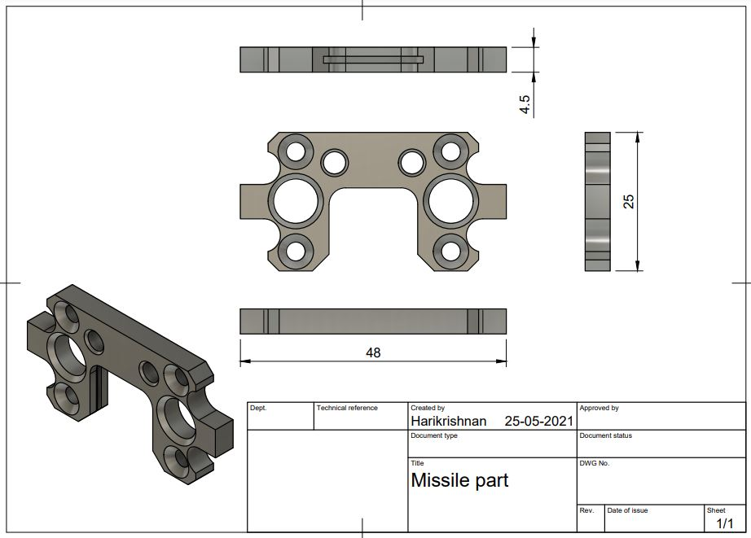

**4.2 Disc Cam**

* Most commonly used cam
* Also known as radial or plate cam
* Converts rotational motion in to translational motion of the follower
* A common example is the camshaft of an automobile, which takes the rotary motion of the engine and converts it into the reciprocating motion necessary to operate the intake and exhaust valves of the cylinders.

**4.2.1 DISC Cam – 2D CAD Model**

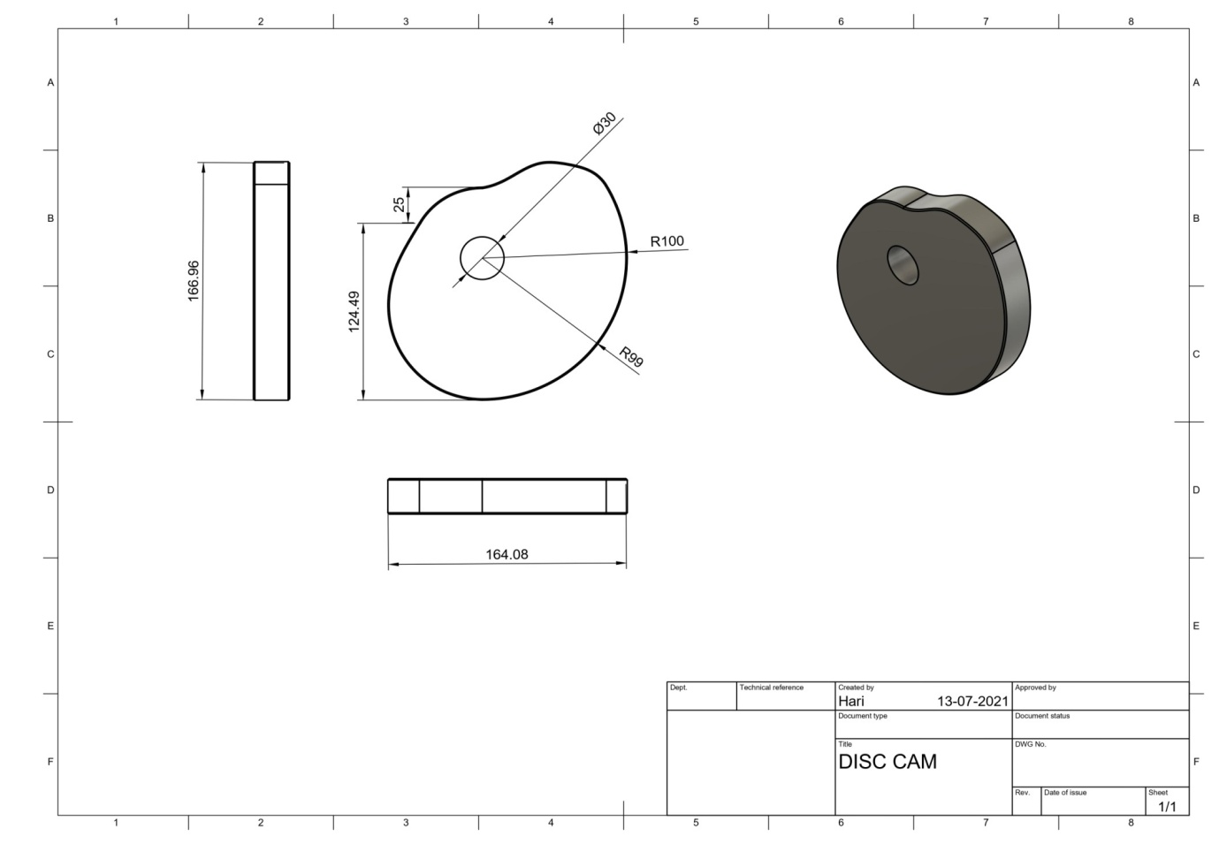

**4.2.2 3D CAD Model**

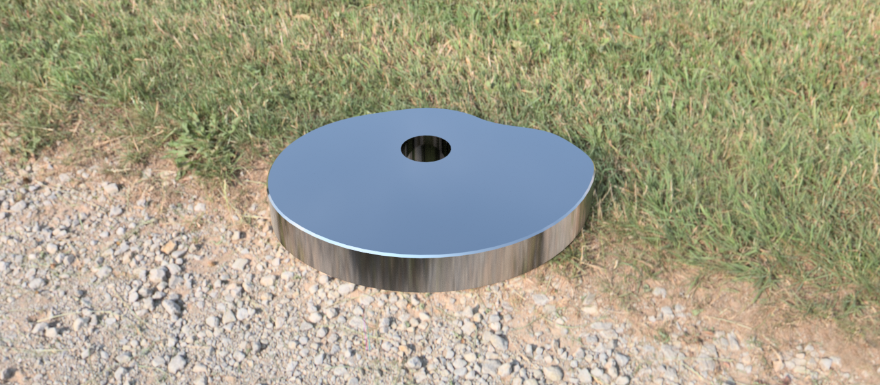

**4.3 Keyboard Cover**

Here what we have done is ,designed a common keyboard cover of student laptop with

following dimensions and specifications.

The material of the keyboard is plastic

**4.3.1 Keyboard Cover – CAD 2D Model**

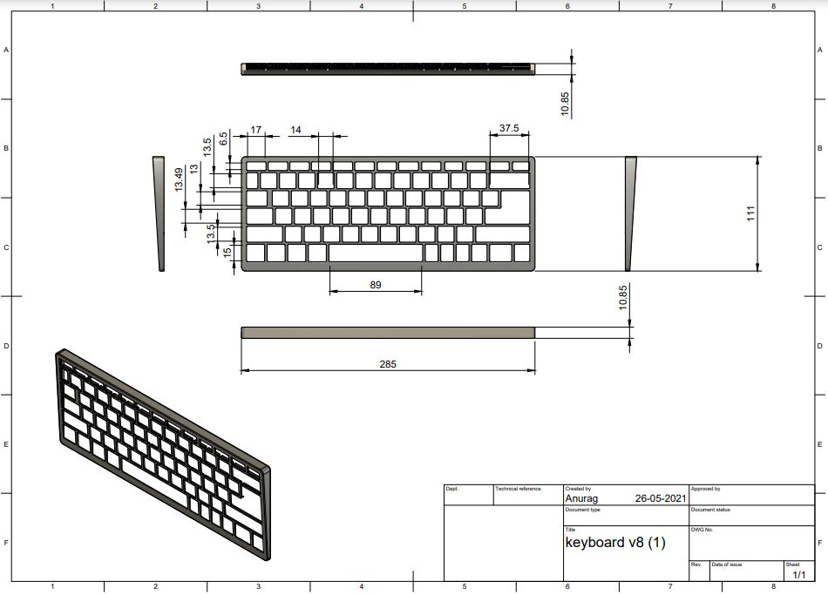

**4.3.2 Keyboard Cover – CAD 3D Model**

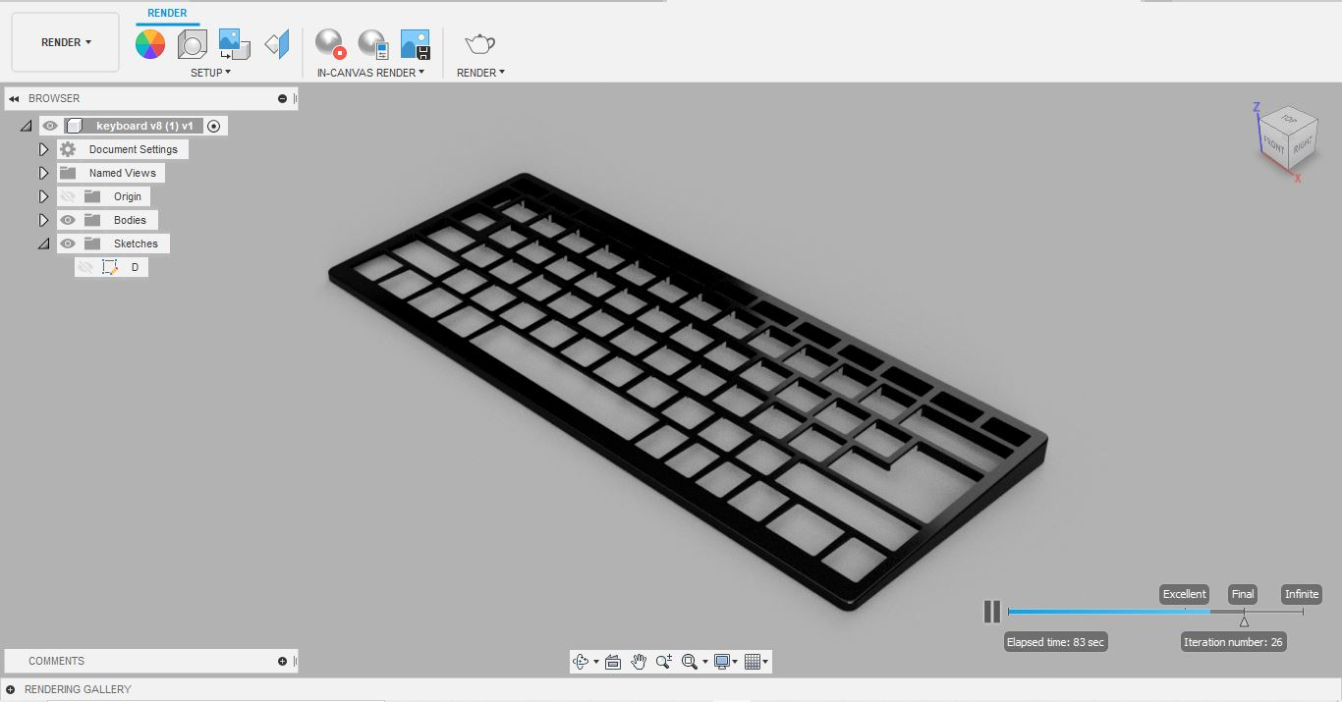

**4.4 Bicycle Sprocket**

Bicycle sprocket is a flexible machine element mainly used in chain drive ie Bicycle

Here we designed Type –A sprocket

**4.4.1Sprocket – 2D CAD Model**

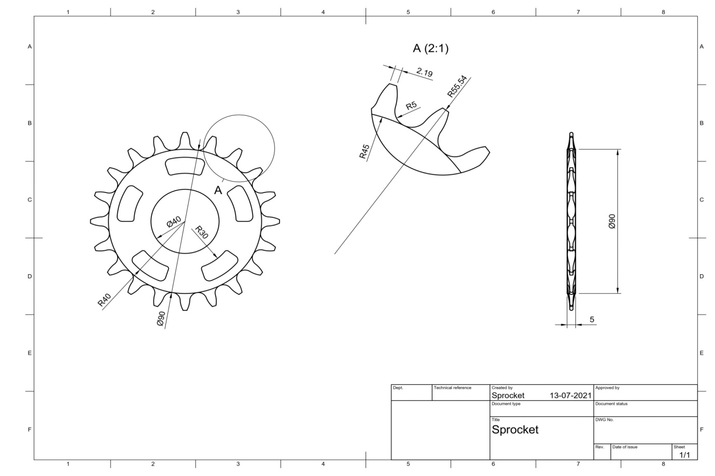

**4.4.2 Bicycle Sprocket – CAD Model**

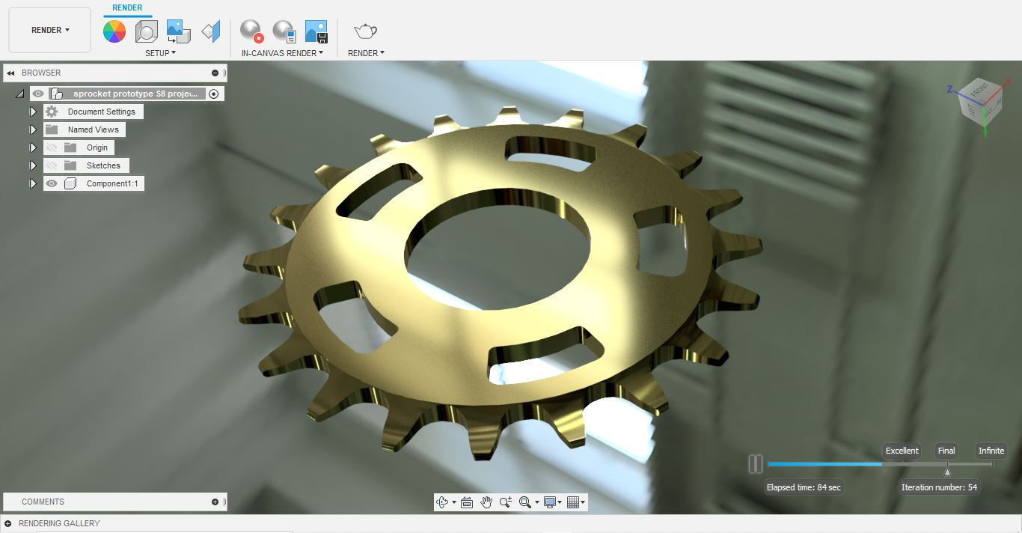

**CHAPTER – 5**

**COMMON COMMANDS USED**

**5.1**

* **Fillet :**Places an arc of a specified radius at the intersection of two lines or arcs
* **Trim :** Deletes a sketch ie nearest intersecting curve or boundary geometry
* **Pipe :** Creates a solid pipe that follows a follows a selected path
* **Revolve :**Revolves a sketch ,profile or planar face around a selected axis
* **Press Pull :** Modifies the selected geometry using offset,extrude, or fillet commands.The operation depends upon the geometry selected.
* **Rectangle :** To draw rectangular shape ie Centre rectangle,Two-Point rectangle,..
* **Polygon :** To draw polygon inscribed or circumscribed
* **Pattern :** To create duplicate surfaces ie circular pattern,square pattern
* **Thread :** To create threaded surface ie ASME thread
* **Line :** To draw lines
* **Extrude :** Adds depth to open or closed sketch profiles or faces

|  |
| --- |
| Learn to create tool paths for CNC using Fusion 360 |

|  |
| --- |
| How to draw arc slots in Sketch mode of Fusion 360 | Fusion 360 | Autodesk  Knowledge Network |

|  |
| --- |
| Tech Tip: Using the Pipe Command in Designs/Solids - Fusion 360 Blog |

*Fillet Slot*

*Pipe*